Unit 9

Kitchen Utensils

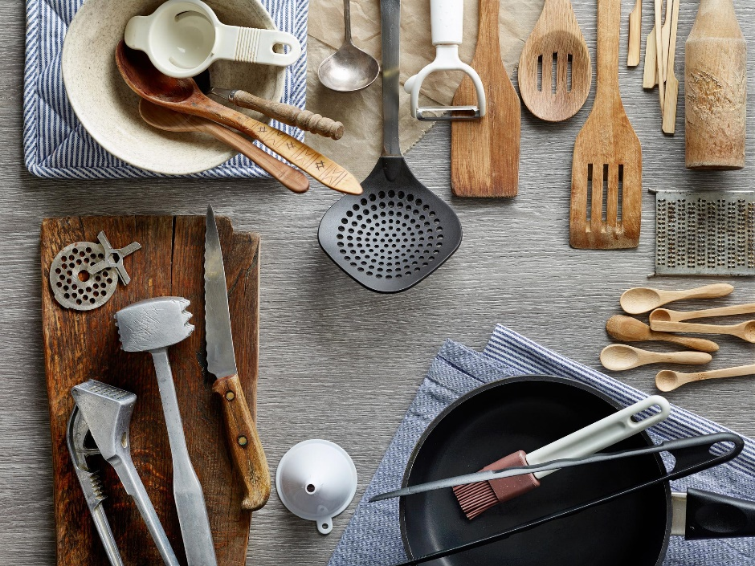

Reading

Tools

Since this is not really a book for those who have never seen a kitchen before, I will describe only briefly the most basic utensils. Every good kitchen needs an assortment of pots, pans, frying pans, skillets, saucepans, casseroles, baking dishes and mixing bowls in a variety of sizes.

As for cutlery, it is perhaps the single most important item in culinary equip-ment. It is necessary to have an assortment of sharp, clean knives, preferably with carbon-steel blades. A large, finely serrated knife for bread, and an extremely thin, sharp vegetable knife are of great importance. Keeping a whet-stone for knife-sharpening is a very good idea, for clean and sharp blades can greatly reduce the preparation time of many dishes. A good kitchen has scales, measures, in cups and spoons, some baking sheets and cake tins, and at least one cutting board.

These are the most fundamental items to anyone who prepares and cooks simple foods. As your ideas move in the direction of more interesting and rewarding cookery, other items take their places among the essential.

Several strainers and sieves, both fine mesh and coarse mesh, are nec-essary.

Please do not consider a pepper mill a luxury. Freshly ground pepper is quite different from stale, commercially ground pepper. Don’t miss it. In the same spirit, equip your kitchen with a good-sized pestle and mortar (preferably of marble) and a heavy, solid garlic press.

The preparation of soups, fresh vegetables, pasta, and rice is a large part of vegetarian cookery. A good colander, a ladle, a slotted spoon, and at least one large pot are used constantly in these preparations. The steaming-basket for vegetables is a marvellous invention: vegetables retain much more of their colour, flavour, nutritional value, and integrity when steamed rather than boiled.

There is one slightly more costly gadget that I do very strongly recommend: a good electric blender. A large part of all grating, chopping, and mashing can be done away with.

Take care in equipping your kitchen. If you enjoy cooking, you spend a good part of your time there, so it should be one of the most comfortable and cheerful rooms in the house and the time spent in it should be rewarding.

Answer the questions.

- What are the most basic kitchen utensils?

- What kitchen utensils reduce the preparation time of many dishes?

- What kitchen utensils help to preserve the nutritional value of vegetables?

- What are the advantages of a good electric blender?

- What piece of equipment is now used instead of pestle and mortar?

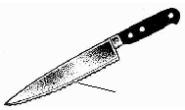

serrated edge

serrated knife

Kitchen

The old kitchen was big but poorly planned. It served all of the Hotel’s outlets, but it could not provide for all the Hotel’s needs. The new chef had a new kitchen built. He designed it himself and was very proud of it.

He put the kitchen on two floors.

Upstairs he built full kitchen to serve the restaurant. Downstairs he cooked for banquets and Room Service. The preparation of certain ingredients needed in the restaurant kitchen | such as soups, stocks and salads | was also done in the basement. So was all the Hotel’s pastry and bread. At the far end of the Hotel there was a smaller kitchen to serve the staff canteen and, next to that, a large finishing station for banquets.

The main kitchen had four solid-top stoves, four small ovens and two grills in addition to 16 bains-marie. Many of the fridges had glass doors because he believed that fridges with glass doors kept themselves clean. No one left a mess when they knew that everyone else could see it.

At the rear there was a huge roasting oven | a relic from the Hotel’s original kitchen. It was large enough to cook eight lambs.

Answer the questions.

- Why was the new kitchen necessary?

- Into what parts was the new kitchen divided?

- What equipment did the main kitchen have?

- Why did the chef insist on having fridges with glass doors?

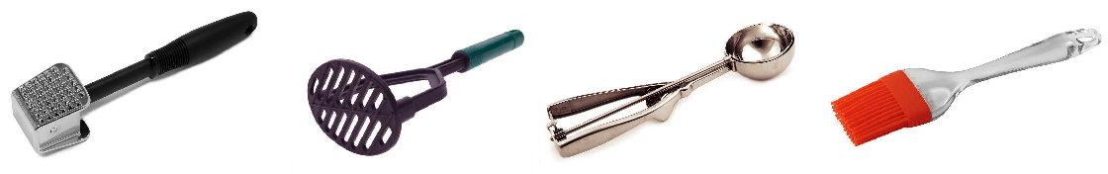

meat tenderizer potato masher kitchen scooper kitchen silicone brush

