Unit 8

Hygiene and Safety

Reading

Hygiene

The cook is responsible for the well-being of the diner. This responsibility must be taken seriously both in restaurant and at home.
It is very important that everyone who handles food, or works in a place where food is handled, should know that food must be both clean and safe.

Hygiene is the study of health and prevention of disease. Hygiene requires special attention from everyone in the catering industry because of the dangers of food poisoning.

There are germs everywhere, particularly in and on our bodies. If they are transferred to food, some of these germs can cause illness and in some cases death. These germs are so small that they cannot be seen by the naked eye. Food which looks clean and does not smell or taste bad may be dangerous to eat if harmful germs have contaminated it and multiplied.

The duty of every employee is to prevent contamination of food by germs or bacteria. The only way to safe food is the practice of hygienic habits. Food poisoning can be prevented by:

- High standards of personal hygiene: clean hands, short nails, no rings or wristwatch, hair tucked into hat, clean chef whites or kitchen overalls.
- Kitchen hygiene: maintaining good working conditions. Kitchen equip-ment should be in good repair and in clean condition.

- Food hygiene: correct storage of foodstufis.

Protection of food from vermin and insects

Insects, rats and mice may be a serious danger to health. They are controlled through periodic extermination. Special traps or poisoned bait may be located where they cannot come into contact with foodstufis. It is also important to throw away wastes regularly and in tightly-covered containers. In many restaurants waste containers are kept on wheeled carts that can be easily and quickly moved to special areas.

Hygiene and safety

Both sanitation and safety require frequent cleaning of the equipment and washing down of the entire area.
Cutting instruments and hot surfaces may cause accidents. The best way to prevent them is by means of industrial safety programs for employees. Mod-ern kitchen equipment has safety devices, such as automatic cut-ofis, to reduce accidents.

One of the biggest dangers in a kitchen comes from grease which is highly flammable. Therefore all equipment where grease can build up must be carefully cleaned every day.

Another necessity is good ventilation. It would remove hot air and cooking odours and pump in fresh, cool air. Modern kitchens are equipped with exhaust hoods. An exhaust hood / extractor hood is a device containing a mechanical fan that hangs above the cooktop in the kitchen. It removes airborne grease, fumes, smoke, odours, heat, and steam from the air by evacuation of the air and filtration.
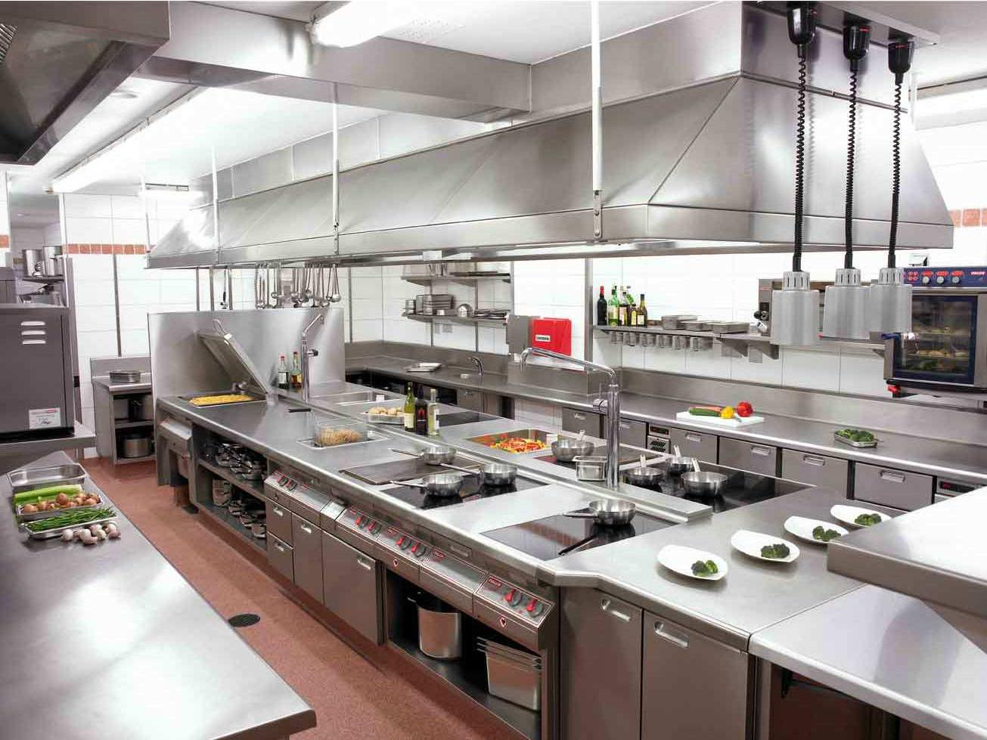

Comprehension check

  - What are the causes of food poisoning?

  - In what ways can food be contaminated by germs or bacteria?

  - Do harmful bacteria change the appearance, smell or taste of food?

  - What do we mean by: a) personal hygiene? b) kitchen hygiene? c) food hygiene? How should different foods be stored and why?

  - Why is it important to wash hands: a) before handling food? b) after handling certain foods?

  - How are insects, rats and mice controlled?

  - What are the main causes of accidents in the kitchen? What kind of accidents often happen in the kitchen?

  - What measures are taken to prevent or reduce accidents?

  - What are the usual causes of fire in the kitchen?

