Unit 4

Parts of Meals: Courses

Reading

A. Hors d’oeuvre

Hors d’oeuvre is the first course of a meal, particularly lunch (dinner usually starts with soup). The terms starter (UK) and appetizer (US) are also used to denote the first part of a meal.

Hors d’oeuvre is usually served at the table. Busy restaurants serve cold starters from trays or trollies. Sometimes the customer may help himself to the offered delicacies from a special table in the dining room. He will then sit down and the rest of the courses will be served by waiters or waitresses.
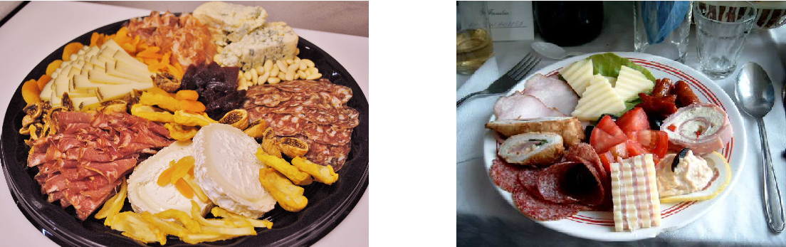

Hors d’oeuvre dishes are light and delicate: they serve just to open (or excite) appetite. Thus the presentation of hors d’oeuvre dishes is very important. Food served as an hors d’oeuvre should be colourful, appetizing, piquant, varied and suitable for the time of year, occasion and meal. Most important of all, it should be fresh, and attractive. There are now quite a lot of foods or dishes suitable for serving as an appetizer or starter to a meal.
There are two main types of hors d’oeuvre: cold and hot.

Cold hors d’oeuvres include the following: fish or seafood which can be either marinated, smoked, in oil, or in vinegar; vegetables µa la grecque (cooked in a marinade flavoured with olive oil and lemon and served cold); cured meat, fresh and smoked sausages, hams; fish roes; various raw vegetables; stuffed or jellied eggs; mixed salads; stuffed grapefruit; prawn cocktail; etc.
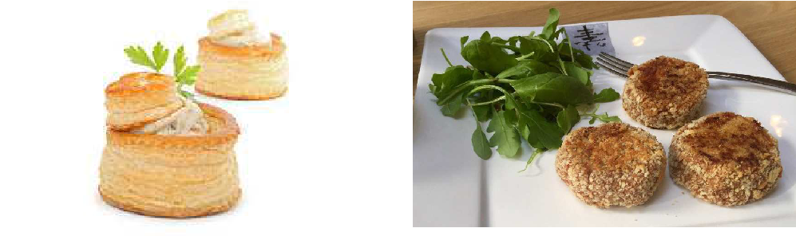

vol-au-vent rissole

a small, light, cup-shaped pastry minced cooked meat or fish coated in egg and
case with a savoury sauce filling breadcrumbs and fried in deep fat

Hot hors d’oeuvres include vols-au-vent, croquettes, rissoles, fritters, etc. These are, in fact, more likely to be served at dinner after the soup, but they may also appear at luncheon.
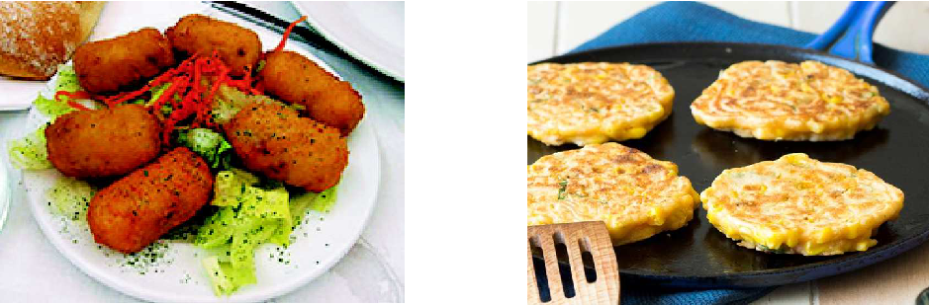

croquette
a small roll of mashed potatoes or some fritter
other vegetable, minced meat or fish, any kind of food coated
coated with breadcrumbs and deep-fried in batter and deep-fried

Appetizers of the Balkan cuisine are most varied, starting from cornbread and a variety of pies and \bureks" to delicious \gibanitsa" (cheese and spinach rolls), and all sorts of cured and smoked meat. A typical Balkan specialty is the so-called \mezze", which in Persian means approximately \snack". It is usually served not in the dining room, but in the room where the guests are received on arrival. \Mezze" is served as accompaniment to drink. It may include various kinds of smoked salt meat, smoked sausages, different kinds of cheese, hard boiled eggs, salt fish, tomato, peppers, small hot peppers, spring onions and garlic, olives etc. Instead of fresh vegetables, the ones from \turshiya", home-made pickles, can also be served. All these delicacies are cut into pieces, diced or sliced, and arranged on trays. As a rule, national aperitifs, like plum or grape brandy, are served with them.

B. Entrée

Today the entrée is usually the main course of the meal. But in a full French menu it is the third course. It is served after hors d’oeuvre (or soup) and fish course, before roasts. There is no doubt that this course contains the best-known dishes in historical as well as modern cookery. These include: stews (ragout), pilaff, moussaka, goulash, hamburgers, kebab, pies, casseroles, fried or grilled fillet steaks, etc.
Entrée dishes have several specific features. First of all, they are prepared from meat, game, poultry or offal, pasta and vegetables. Secondly, the meat, game, poultry or offal for this course is always cut or portioned before cooking or processing. In this it differs from roasts, which are either cooked whole or as a large joint and then carved and portioned.

A third feature of an entrée is the methods of cooking applied to the cuts or portions of meat. They are: stewing, sautéing, frying, baking (pies, etc.). Sometimes grilling is added where individual cuts of meat are offered as entrée , especially on luncheon menus.

Dishes used as entrée s are of the re-heated variety. An entrée dish should be complete in itself. It is served with or in its own sauce and/or garnish, therefore it does not need vegetables or potatoes other than those which go to make up the dish or recipe. Special garnishes and sauces are served with each individual dish. Thanks to them each dish has a particular flavour and appearance.
Entrée s include numerous dishes. The best way to classify them is according to the cuts of meat and preparations used. So there are minced meat entrée s, diced or sliced meat entrée s, cut meat entrée s. Some entrée dishes such as vol-au-vents, tournedo, are suitable for dinner menus, and stews, meat pies are suitable for luncheon menus.

Answer the questions:

- 1. What English terms are used for the French \hors d’oeuvre"?

  - What are the main ways of serving hors d’oeuvre?

  - What is the aim of the hors d’oeuvre?

  - What are the main requirements for hors d’oeuvre dishes?

  - What kinds of food and dishes may be served as an hors d’oeuvre?

  - What foods may be served as a starter in Serbia?

  - What food does mezze include?

- 1. What place in the meal does the entrée occupy now?

  - What are the specific features of entrée dishes?

  - What are the most popular entrée dishes?

