Unit 7 Breakfast

Pre-reading task

1. In international catering it is customary to speak of different kinds of breakfast.

What are they called? What do they consist of?
Which of them is the most substantial? Which is the lightest?

Reading

Breakfast
Hotels and other types of lodging facilities in Europe usually include breakfast in their room rates. In many cases, especially in larger hotels, they serve buffet breakfast, which is a kind of a meal where people help themselves to different types of hot or cold food arranged on a table or counter. Buffet breakfast is becoming more and more popular in hotels. Food will vary from country to country, depending on local breakfast tastes and habits.
Traditionally, people in Britain and Ireland have enjoyed a substantial hot meal for breakfast, which consisted of eggs, boiled, fried or scrambled, bacon, and sausages, accompanied by toast and tea or coffee. Many other dishes (for example, kedgeree, grilled or fried tomatoes, black pudding, baked beans, fried sliced bread, fried potatoes and mushrooms) may be included depending on taste and location. Another popular breakfast food in England is the kipper, a type of salted, smoked herring that is then grilled, fried, poached or steamed.
Today, these dishes remain popular, but are not usually served at breakfast time during the week. A lot of people eat the full cooked breakfast at weekends at home, or go to a cafe or pub for it at the weekend. It is also served in hotels where it can be quite substantial, and is included in the room rate. This full cooked breakfast is called English breakfast.
A full breakfast is a meal available any time at many cafes. A famous English writer once joked that “the only way to eat well in England is to have breakfast three times a day”.
This traditional cooked breakfast has been replaced by simple, light foods mainly eaten cold: fruit, yogurt, cornflakes or breakfast cereals with cold milk, and toast with a variety of spreads such as butter, jam, marmalade, or peanut butter. Boiled eggs are also popular. Porridge is a traditional breakfast in Scotland as well as the rest of Britain in the winter months.
Continental breakfast is a light meal. A typical continental breakfast consists of coffee and milk or hot chocolate with sweet cakes such as brioche

and pastries such as croissant, often with a sweet jam, cream, or chocolate filling. It is often served with juice. Continental breakfast may also include sliced cold meats, such as salami or ham, yogurt or cereal. Some countries of Europe add cheese (Switzerland), or boiled eggs (Austria) to the bread menu.

Exercises

Read the following examples of breakfast menus. Say which of the following kinds of breakfast each menu offers:
Simple / Continental / Swiss / Viennese / English

a)
GOOD MORNING!
Breakfast is served from 7:00 a. m. until 11:00 a. m. daily
Fresh Orange or Grapefruit Juice, Pineapple, Tomato Juice
Porridge or Cereal
Two Eggs, any style with choice of
Ham, Bacon, Sausages or Grilled Tomato
Croissants, Brioche, Breakfast Rolls or Toast with Butter and Marmalade, Jam or Honey
Tea, Coffee, Chocolate or Milk

b)
Coffee with Milk Butter
Jam or Honey Soft-boiled eggs Bread, Pastry
Cocoa, Coffee Butter
Jam or Honey Cheese
Bread, Pastry
Tea, Coffee with Milk Bread, Pastry
c) d)

e)
GOOD MORNING!
Breakfast is served from 7:00 a. m. until 11:00 a. m. daily
Fresh Orange or Grapefruit Juice, Pineapple, Tomato Juice
A basket of Croissants, Brioche, Breakfast Rolls, and Toast with
Butter and Marmalade, Jam or Honey Tea, Coffee, Chocolate or Milk

Match the word with the description.
porridge — a kind of hard, dry biscuit often made from a piece of bread baked hard;
rusk — a type of brown bread made from wholemeal flour (wholemeal flour is made without remov- ing the outer covering of the grain);
cereal — a special sort of long red sausage in a bread roll;
hot dog — a type of soft breakfast food made by boiling crushed grain in milk or water (kaˇsa)
wholemeal bread — food made from grain, esp. eaten at breakfast

Write the letter of each item next to the correct word or words.
A breakfast tray
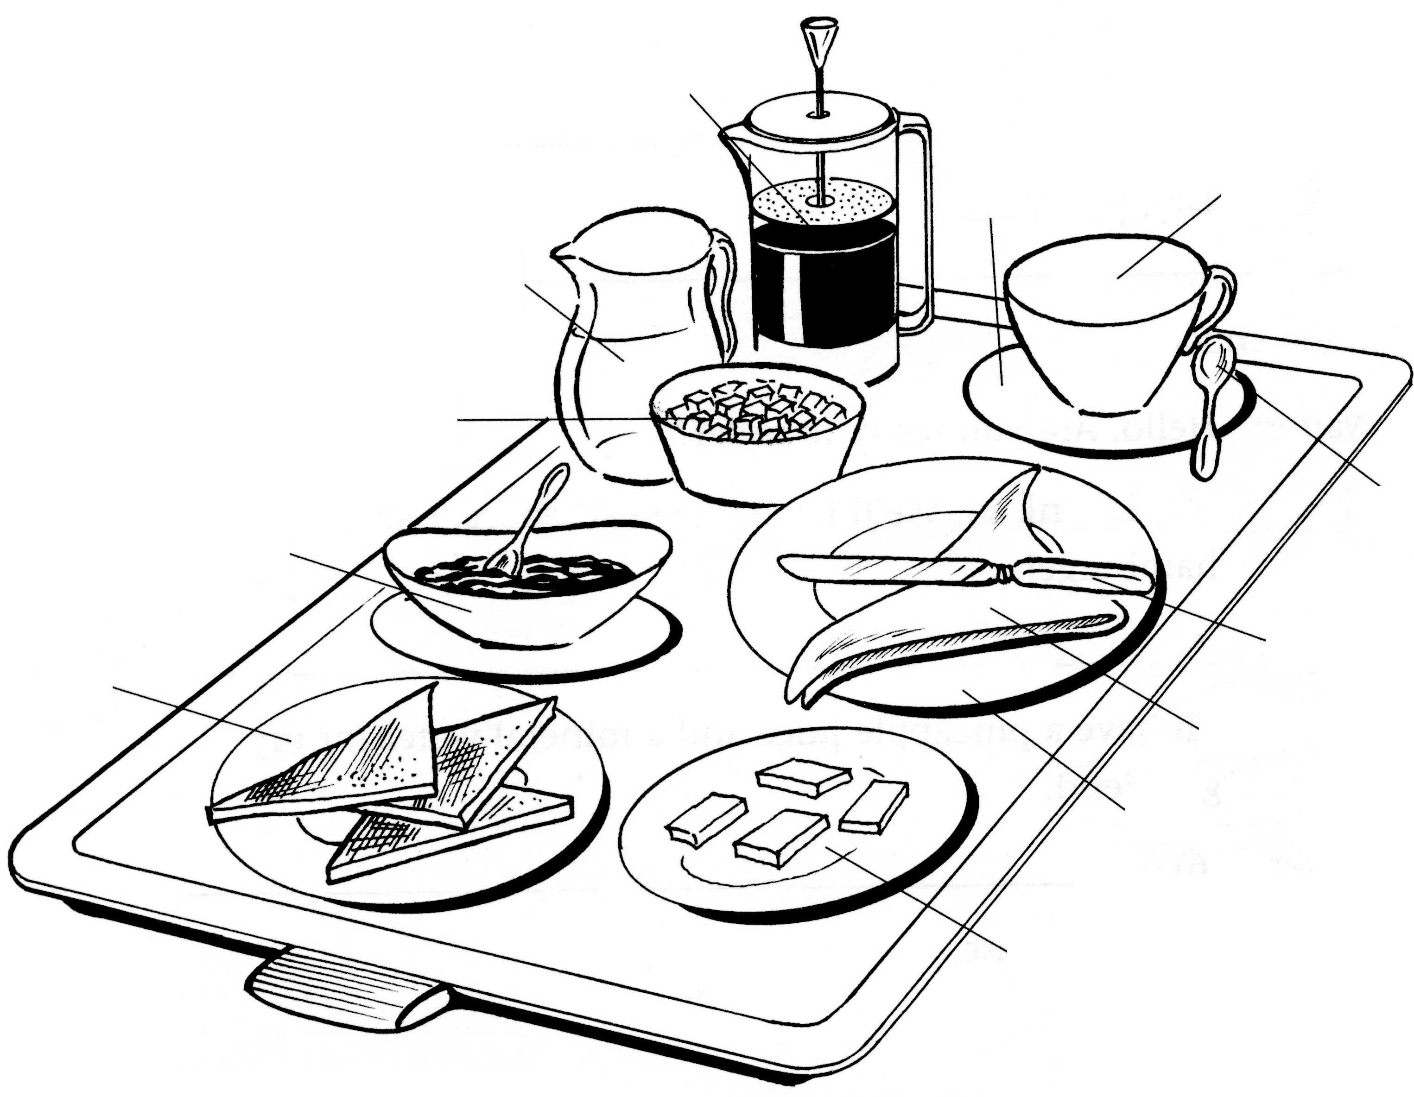
a
e
d
b
c
g
f
k
i
j
h
l

butter dish dessert plate small napkin small knife
coffee pot sugar bowl toast plate milk jug
saucer
cup teaspoon jam dish

Writing

Translate into English
  - Kad se u vašem hotelu služi doručak?
  - Možemo li doručkovati u sobi?
  - Mi obično jedemo lagan doručak.
  - Ovo je prerano za nas.
  - Recite, molim vas, broj vaše sobe.
  - Obično ne služimo hranu u sobama.
  - Doručak obično ne služimo posle deset.
  - Odmah ću doći.

Name several kinds of breakfast food
egg dishes: cereals: spreads: bread: milk products: hot beverages:

Fill in the following crossword.

  - The meat we get from a cow.
  - The meat we get from a calf.
  - A vegetable.
  - The meat we get from a sheep.
  - A fruit.
  - Another sort of meat.
  - These vegetables make you cry!
  - A bird often served with orange sauce.
  - The most popular drink in England.
  - Fruit. Also a colour.
  - It makes things taste sweet.
  - English people often eat fish and .

