Unit 4
Laying the Table

Practice

Exercises

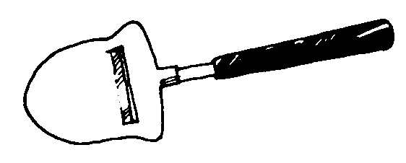
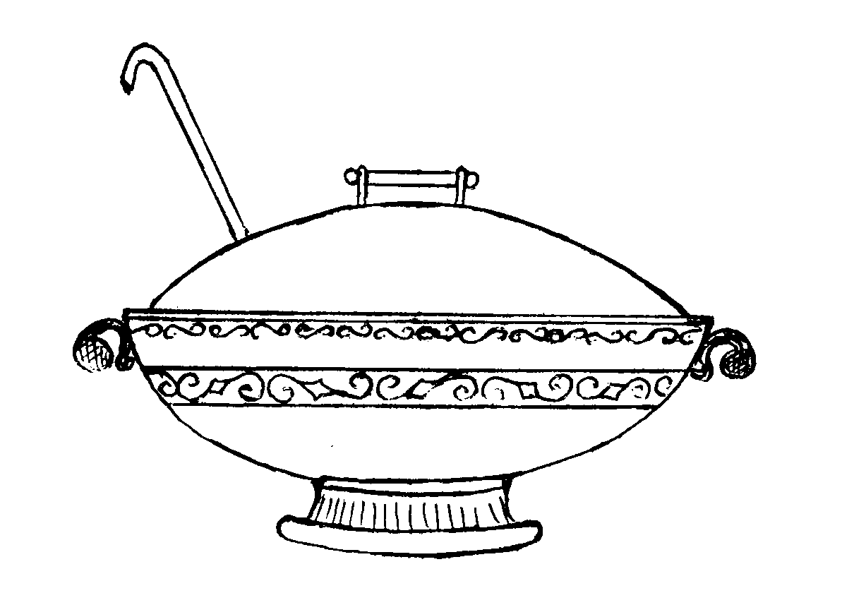
Write the letter of each item next to the correct word.
A
B
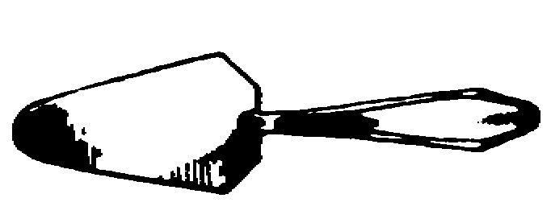
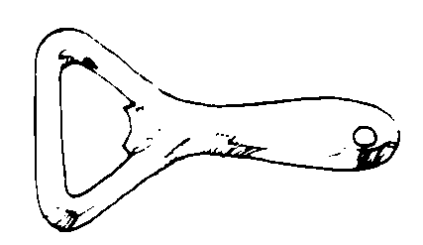
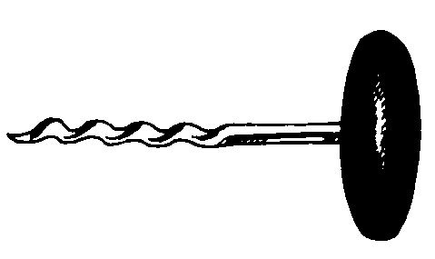
C D
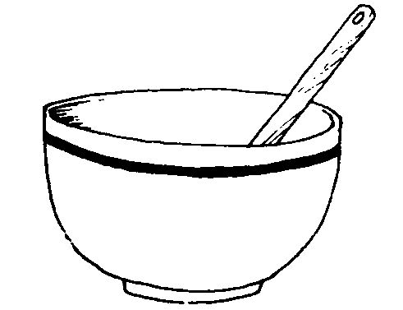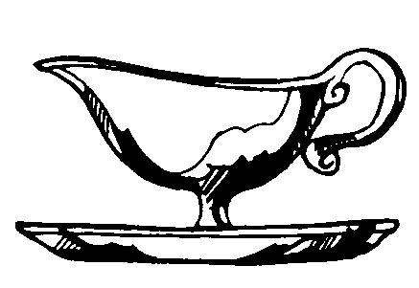
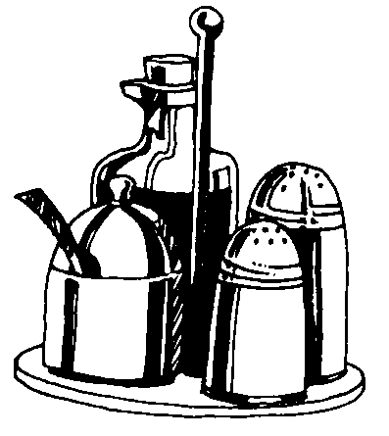
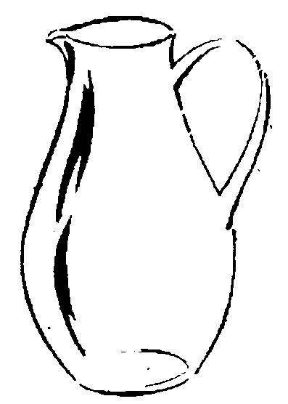
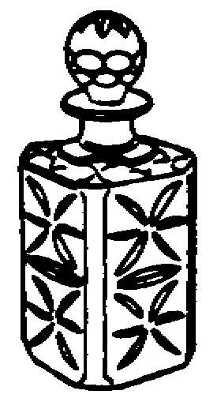
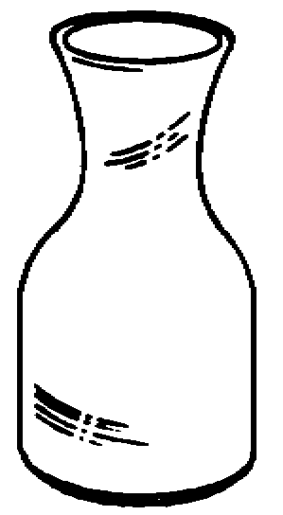
E F G H
J
K

M
L

I

cruet stand
cake server
salt shaker
carafe
tureen
bowl
bottle opener
decanter
N O Q

mustard pot
water jug vinegar bottle ladle
pepper shaker cheese server sauce boat
corkscrew

Write the names of:
  - parts of a fork
  - parts of a knife
  - kinds of plates
  - kinds of forks
  - kinds of knives

Explain the use of table utensils. Use one of the following patterns:
- It is used for serving cakes.
- We serve cakes with it.

Write the nouns in the plural.
Knife
Glass, dish, pepper box
Bottle, carafe, ladle, handle, plate Lid, cup, spoon, fork

Complete the following sentences using the suggested words.
glasses / table cloth / jug / bottle opener / holders / cover / china / soup plate / carafe / tray / corkscrew / ladle / tureen / cutlery / platter / pot / dinner plate
- The dining table was covered with a white . White napkins were rolled in silver . At each place there was a for the main course and on it a .
- Mary laid the table nicely with the best and the lace table cloth.
- The waiter brought a of wine and put it on the table.
- The waiter opened a bottle of wine. He put the on the table and poured the wine into two wine glasses.
- Ellen liked to sit down to dinner with every course on the table: a
of soup, a covered bowl of hot vegetables, a of meat, a sliced pie or cake in the center, and a of coffee.
- In a self service cafeteria the customer chooses his dishes and selects the appropriate for the meal.
- The waiter removed the silver from the dish and the aroma of the steak filled the air.
- We couldn’t help ourselves to the soup as there was no in the tureen.
- There was a of water on the table with ice cubes floating on top.
- The waiter came in holding in both hands a with four cocktail
on it.
- The waiter pulled a from his pocket and opened the bottle of beer.

Arrange the words into the groups. Some words can be used more than once.
  - water jug, fork, tureen, ladle, knife, dinner plate, sauce boat, beer glass,
bowl, table spoon, dessert plate, coffee cup, water glass, milk jug, coffee
pot, ash tray, salad bowl, salt shaker, tumbler, wine glass, soup plate, tea-pot, butter dish, sugar bowl, service plate
- cutlery:

- glassware:

- china (crockery):

c) cover:

Crossword puzzle. Guess the word by its description. Then read down the box to find one more word.
1
2
3
4
5
6
7
8
9

- a small glass bottle for oil or vinegar;
- a boat-shaped dish for serving sauces at meals;
- a tool for cracking the shell of a nut;
- a piece of cloth used for cleaning one’s hands and lips during a meal;
- a container with small holes in the top for shaking salt at meals;
- a container in which wine is cooled or kept cool;
- a large deep dish with a lid from which soup is served at the table;
- a large deep spoon with a long handle used for lifting liquids out of a container;
- a deep round container open at the top for holding fruit, flowers, salads, sugar, etc.

Give the English for the following words:
  - salveta, stolǌak, duboki taǌir, desertna kasika, qasa za vino, porcelan, soǉa i tacna, stolǌak, servirni sto, poklopac, posi-
paq za so, posipaq za biber, srebrno posu$e, qinija za salatu, boqica za sirke, zupci viǉuske, vadiqep, slamqica, supijera, ve- lika plitka qinija, bokal za vodu, staklena boca za vino, kuver, otvaraq za flaxe.

